CHANGES

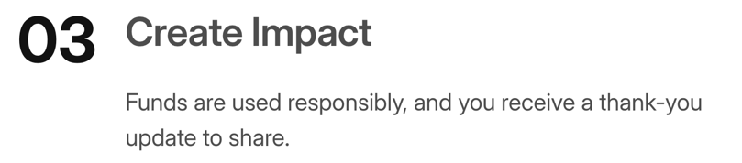
Add: receive updates and a thank-you / Track instead of create
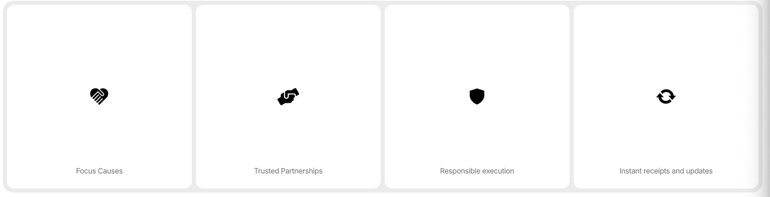
Remove logos
add 01 02 like csr page in the centre
01 - Focused Cause – change this since its only one cause
bold these – Focused, Trusted, Responsible & Instant
capitalise e in execution & r & u in receipts and updates
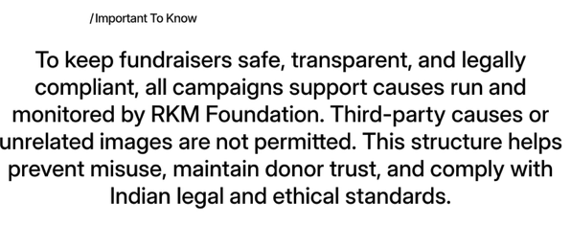
Remove this from here – lets put this in the end near what you will get section – too alarming for this place
"All funds support RKM-run causes only—no third-party campaigns. This protects donors and keeps us legally compliant."

Create Your Campaign – need to make the template – need to discuss this
Call to Action (CTA)
Keep only one CTA button:
Start your fundraiser
Rule: Clicking the CTA should open the fundraiser flow or template on a new page.(we need to discuss this so please call for this)

Faqs – remove from here
Section 7: FAQs
- Duplicate question ("What details can I customise") appears twice—remove one.


We’re here to help
If you need any assistance, please explore our FAQs in the footer or reach out to us at info@rkm.support.
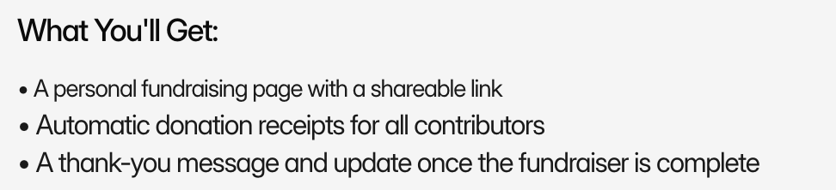

“What You’ll Get” Section – font should be the same size add important to know here
Join Us" button → "Launch My Fundraiser"
“Important to Know” Section
To keep fundraisers safe, transparent, and legally compliant, all campaigns support causes run and monitored by RKM Foundation. Third-party causes or unrelated images are not permitted. This structure helps prevent misuse, maintain donor trust, and comply with Indian legal and ethical standards.

Image & Formatting
Discuss this with me first
1) Left + Right Alignment – Needs to be aligned
2) Font size & font - Needs to be same across the website & which font are you using
3) Padding gaps – needs to be same after each section
4) Image change – need to discuss all website images – need help by creating a bank of images and then placing them
5) old content (hidden) – delete
6) images should be shown full – or should take the pages shape
CTA
I FEEL AT THE START OF THE PAGES – ALL PAGES WE SHOULD HAVE A CTA – EXAMPLE – CSR – CONNECT NOW

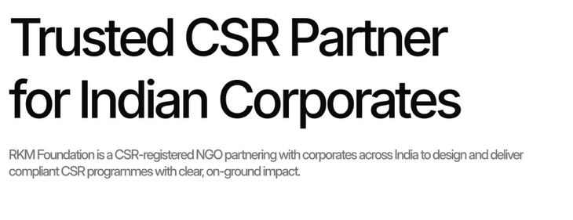
Like how in the csr page you kept things left aligned here you have kept it on the right side
POPULAR FUND RAISER – LETS DELETE ONE – THE LAST ONE – ANIMAL LOVERS DRIVE

